Lab Assignment 12
Stepan Shkrobak
Dr. Michael Bartolacci
IST 894, Section 001: Capstone Experience,
19 April 2026

Table of Contents

Table of Contents 1
General Context 2
Technical Context 3
Screenshots 5
References 16

General Context
The 2 labs, Post-Exploitation with the Meterpreter Lab and Secure Coding - JavaScript from OWASP Top 10 Cyber Range, covered how common system and application weaknesses can be identified and abused, and how those same weaknesses can be prevented through better development practices. The lab showed how attackers take advantage of trust relationships within systems, such as built-in administrative tools or application features, to gain unauthorized access. It also showed how seemingly small misconfigurations like weak input validation or insecure defaults can escalate into serious security issues such as full system compromise or data exposure (CISA, 2024; OWASP Foundation, n.d.).
The lab showed the general lifecycle of an attack. This includes the initial access, persistence, privilege escalation, and data collection. The lab showed how attackers can move from limited access to full control of a system by chaining together multiple weaknesses. For example, once access is gained, attackers can extract credentials, monitor user activity, and manipulate system files, which can ultimately impact confidentiality, integrity, and availability. This showed the importance of layered security controls, such as endpoint protection, monitoring, and secure configuration management, rather than relying on a single defensive mechanism (CISA, 2024).
The secure coding lab showed that many of the risks we have seen originate during software development. Specifically, it showed how improper handling of user input and reliance on outdated or vulnerable libraries can introduce critical vulnerabilities into applications. Prototype pollution in JavaScript, for instance, can allow attackers to modify core application behavior and potentially execute malicious code remotely. This overall shows how important it is to integrate security early in the development process (OWASP Foundation, n.d.; MITRE, n.d.).

Technical Context
The 2 labs, Post-Exploitation with the Meterpreter Lab and Secure Coding - JavaScript from OWASP Top 10 Cyber Range, covered offensive and defensive techniques across both host-based exploitation and application-layer vulnerabilities. On the offensive penetration testing side, some post-exploitation activities using frameworks such as Metasploit included establishing command-and-control (C2) channels, upgrading shells to more advanced payloads, and performing privilege escalation. Techniques such as process migration, credential dumping from the Security Account Manager (SAM), and keystroke logging also showed how attackers maintain persistence and harvest sensitive data after initial compromise. This demonstrated the concept of living off the land, where legitimate system processes or binaries were used and abused for illegitimate purposes to evade detection.
Lateral movement is a goal of many attacks, along with credential harvesting, which is what was also seen and focused on. Multiple mechanisms for obtaining credentials were seen, including memory scraping, forced authentication via SMB, and offline password cracking using extracted hashes. This aligns closely with MITRE ATT&CK techniques such as Credential Dumping (T1003) and Exploitation for Privilege Escalation (MITRE ATT&CK, n.d.). This was then further paired with evasion techniques such as timestomping (modifying MACE attributes) and clearing event logs, showing how attackers attempt to avoid leaving footprints.
In regards to the secure coding, the lab focused heavily on JavaScript prototype pollution and its impact on application security. Vulnerabilities in object merge functions like Hoek and Lodash libraries allow attackers to manipulate the prototype chain via properties such as __proto__, resulting in unintended property inheritance across objects. This can lead to logic corruption, privilege escalation within the application context, or even remote code execution when combined with insecure runtime configurations. Mitigation strategies were raised, including strict property validation, use of hasOwnProperty checks, and secure coding patterns that prevent prototype chain manipulation. This reinforces a DevSecOps mindset, where security testing and secure development are continuous and integrated processes rather than isolated activities (MITRE, n.d.; OWASP Foundation, n.d.).

Screenshots
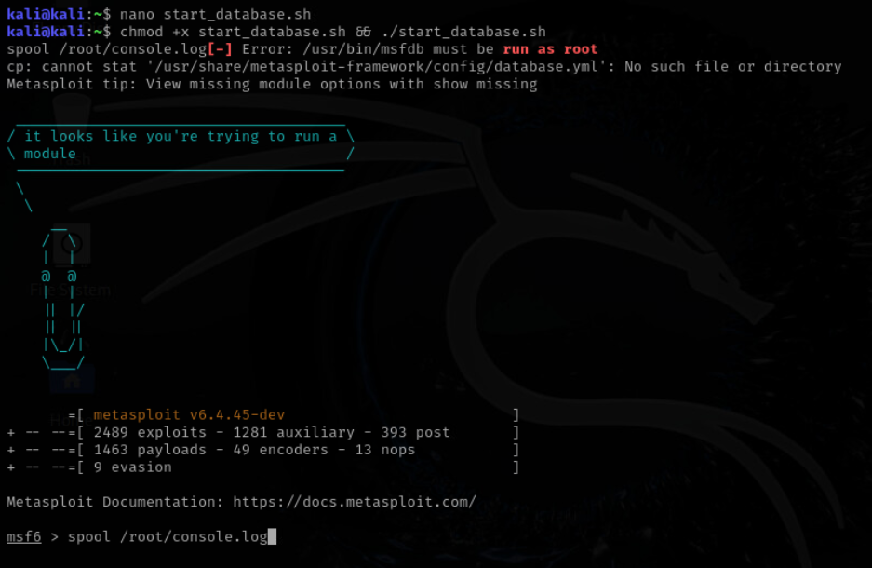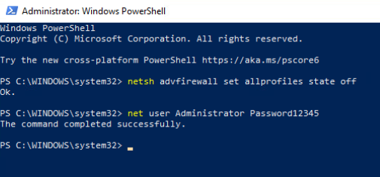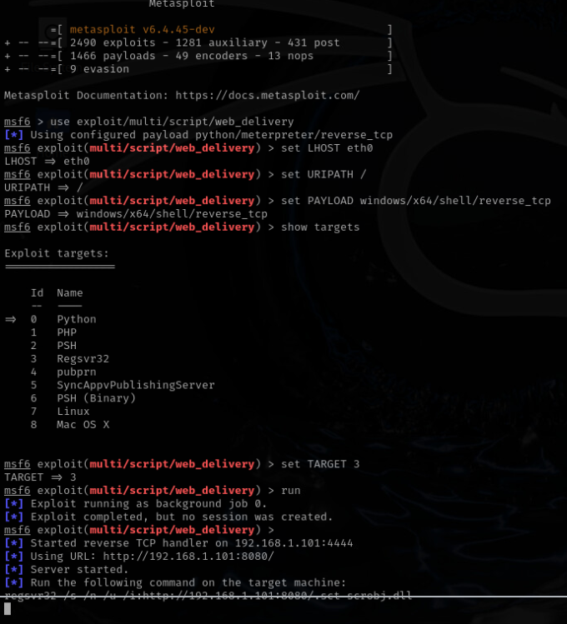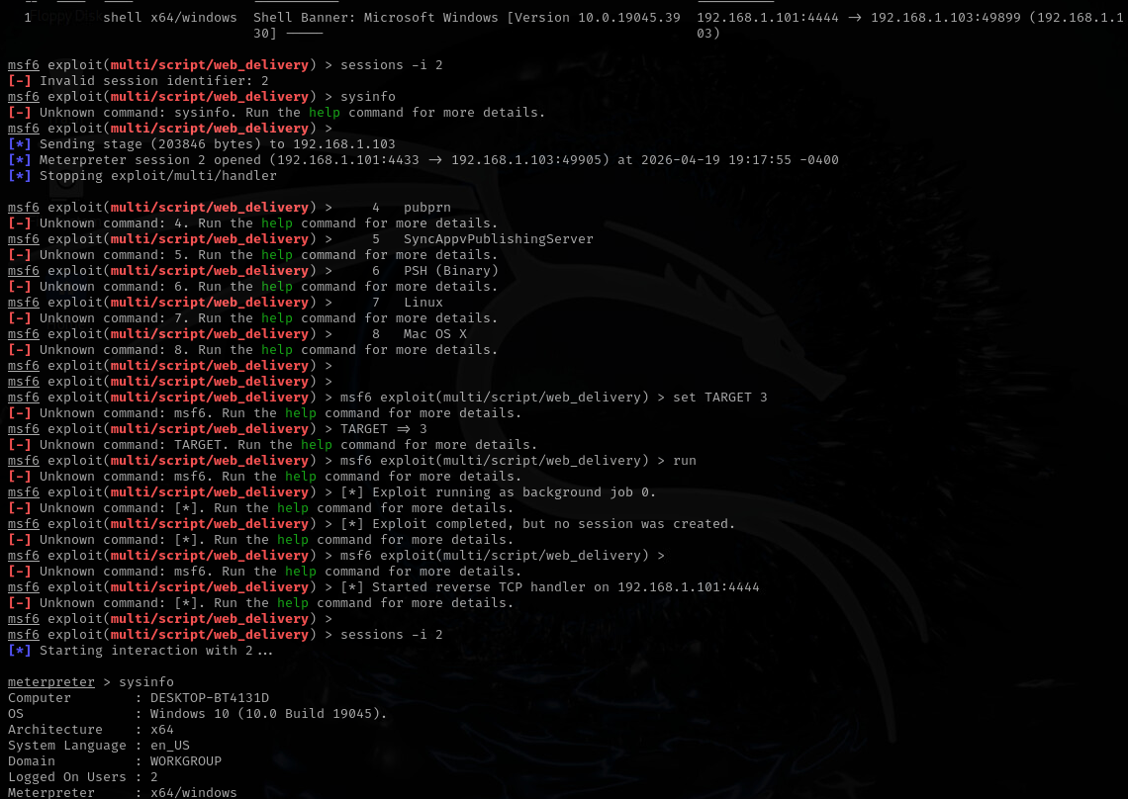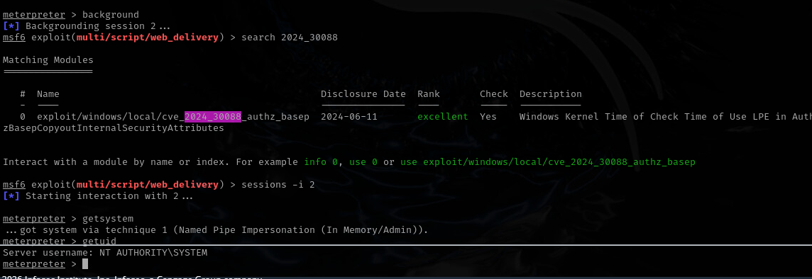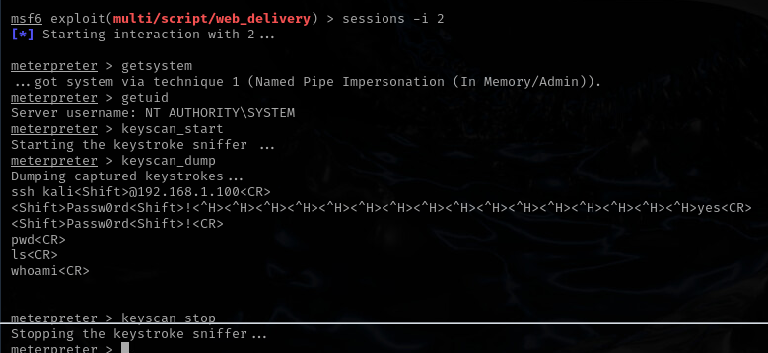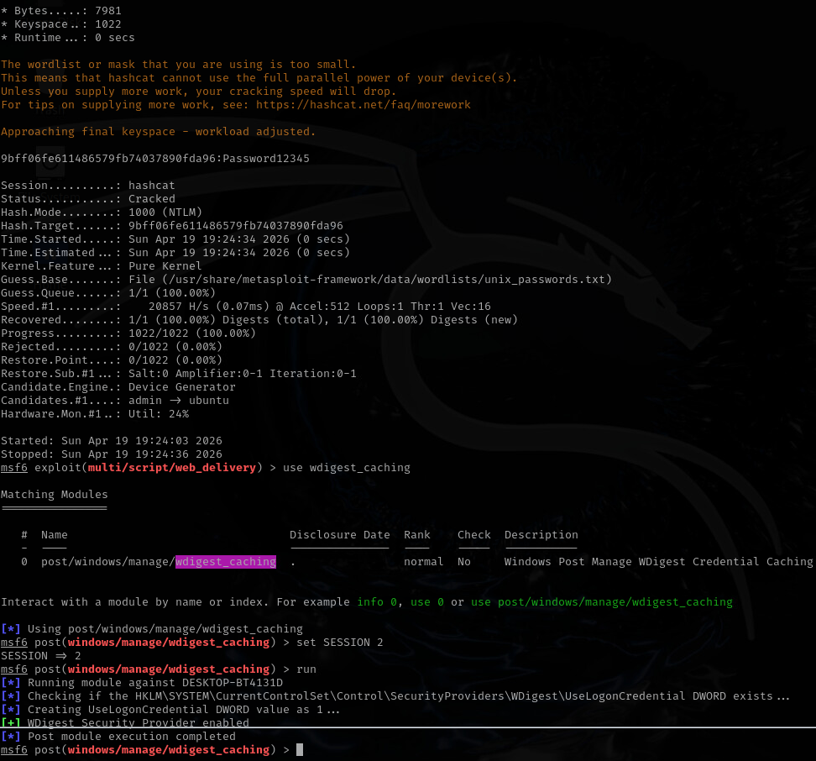

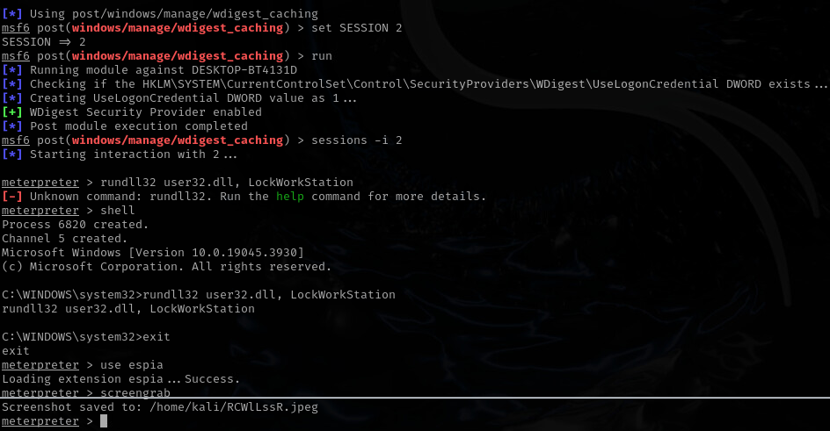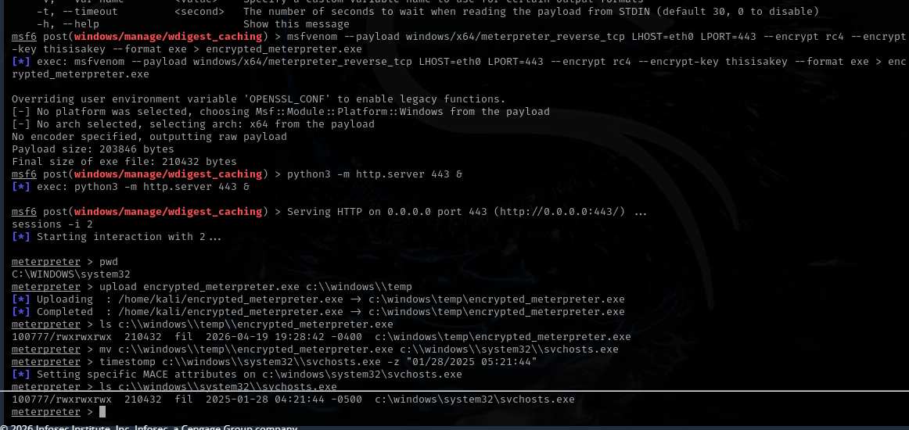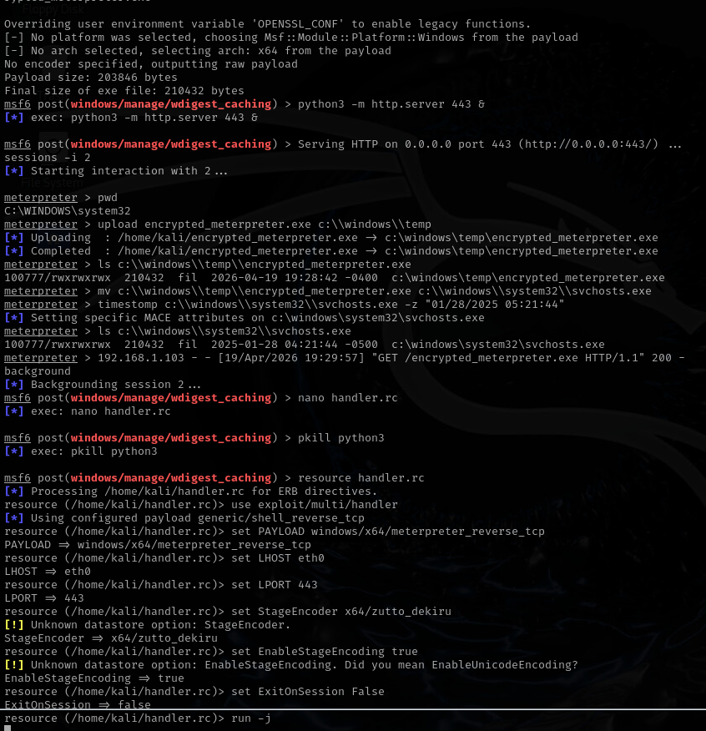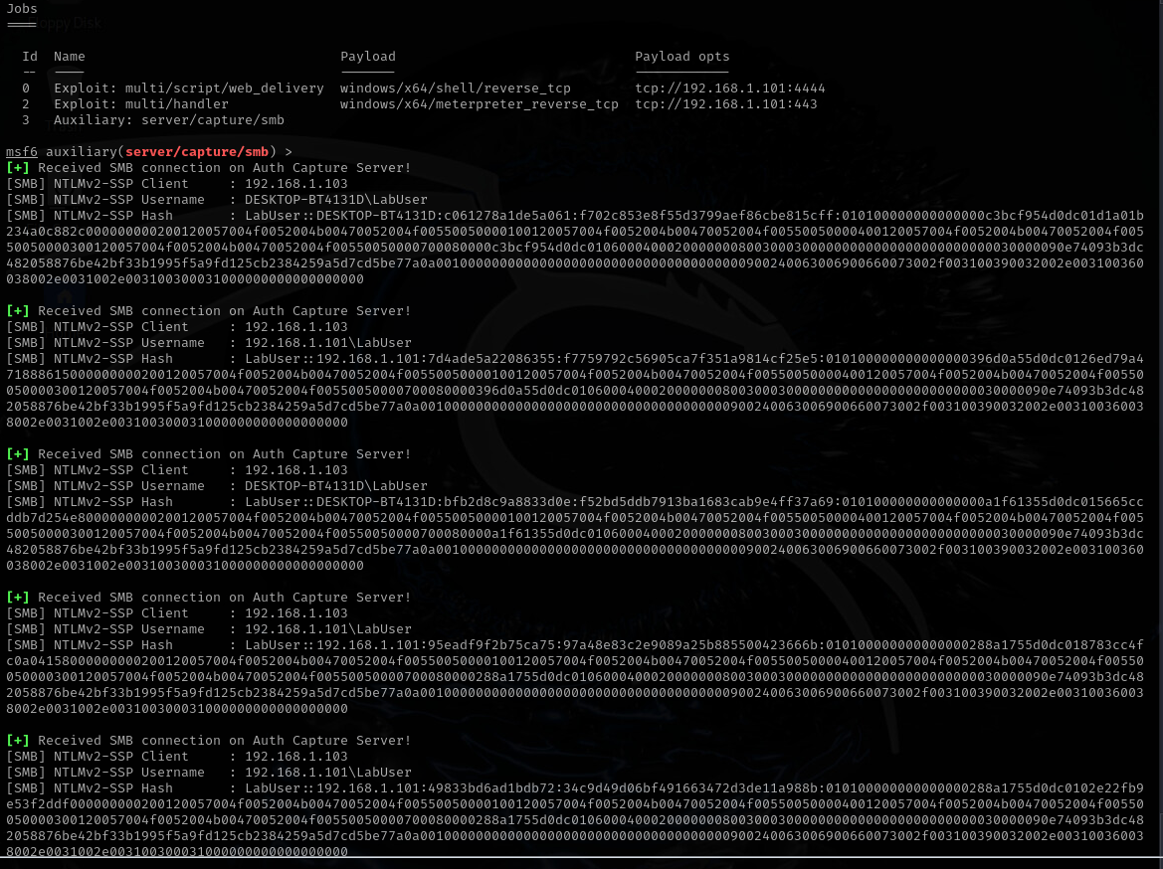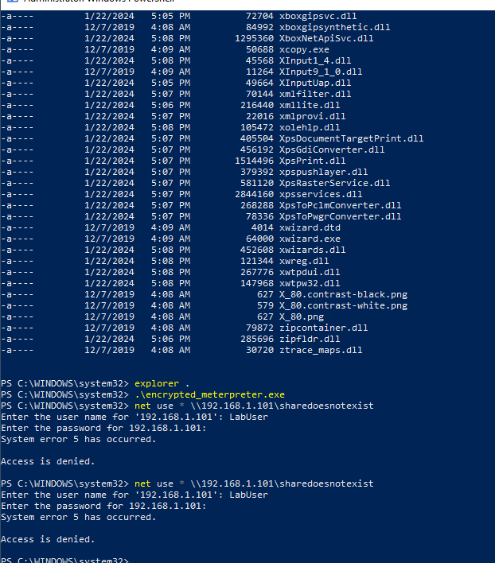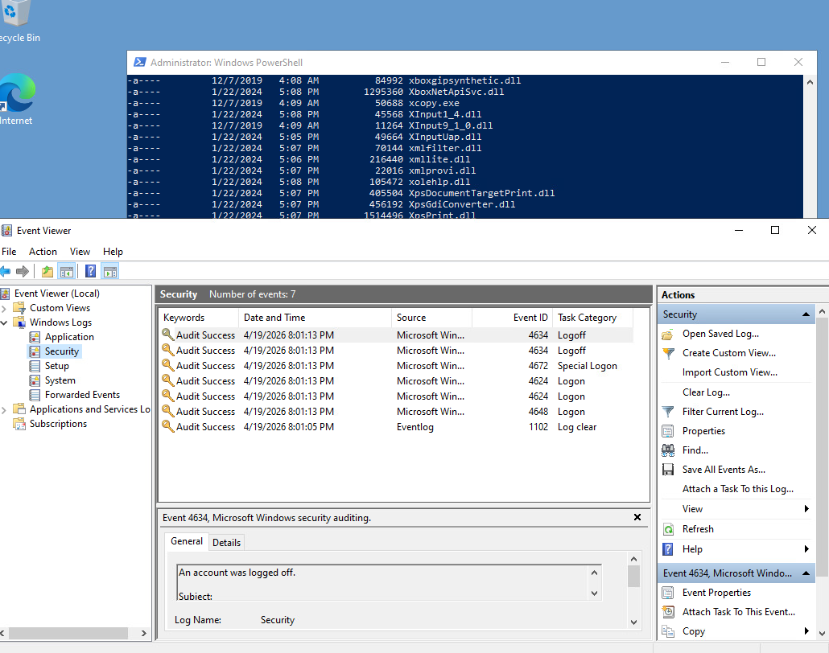

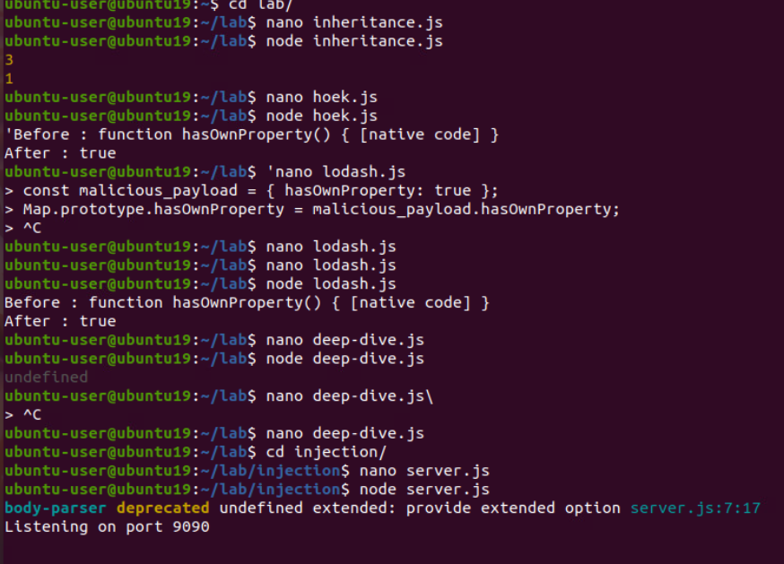

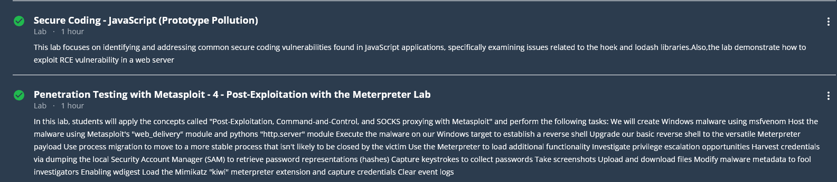

References
Cybersecurity and Infrastructure Security Agency. (2024, February 7). Identifying and mitigating living off the land techniques. https://www.cisa.gov/resources-tools/resources/identifying-and-mitigating-living-land-techniques
MITRE. (n.d.). CWE-1321: Improperly controlled modification of object prototype attributes (“Prototype Pollution”). https://cwe.mitre.org/data/definitions/1321.html
MITRE ATT&CK. (n.d.). OS credential dumping (T1003). https://attack.mitre.org/techniques/T1003/
OWASP Foundation. (n.d.). Prototype pollution prevention cheat sheet. https://cheatsheetseries.owasp.org/cheatsheets/Prototype_Pollution_Prevention_Cheat_Sheet.html

